Creating table for employee salary:

create table emp_salary(

    emp_id int primary key,

    emp_name varchar(20),

    salary int

);

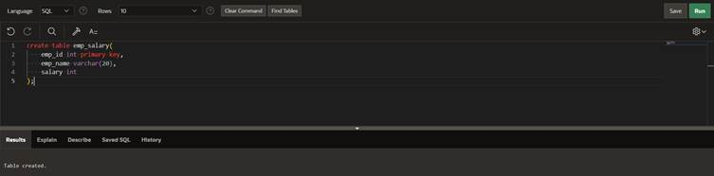

Inserting values in table:

insert into emp_salary

values(1,'rupesh',10000);

insert into emp_salary

values(2,'harshit',20000);

 insert into emp_salary

values(3,'uday',30000); 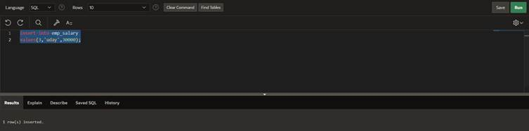

creating plsql with raise application error for exceptions:  
declare

e_name exception;

pragma exception_init(e_name,-20100);

v_name emp_salary.emp_name%type:='harshi';

begin

delete from emp_salary

where emp_name =v_name;

if sql %rowcount =0 then

raise_application_error(-20100,'invalid name');

else

dbms_output.put_line('row deleted');

end if;

exception

when e_name then

dbms_output.put_line('employee name is not found ');

end; 